**NAME: Md Al-Amin.**

**ID: IT-15009**

**Report No: 01**

**Name of Experiment: Linux installation step by step.**

**Objective:**

Aim: The main aim of using Linux operating system.

* Security: It provides virus protection and strong security than other operating system like Microsoft OS.
* Cost: It is open source so it’s cost free.
* Software: It provides many kinds of software for doing any specific task.
* Hardware: Linux is perfect for those old computers with barely any processing power or memory we have sitting in our garage or basement collecting dust. Install Linux and use it as a firewall, a file server, or a backup server.
* Flexibility: We don’t have to deal with anti-piracy schemes and additional “hoop jumping”.
* Understanding: Becoming familiar with the Linux operating system requires patience as well as a strong learning curve. We must have the desire to read and figure things out on own, rather than having everything done for we
* Compatibility: Though the kernel contributors and maintainers work hard at keeping the kernel up to date, Linux does not have as much of a corporate backing as alternative operating systems. Sometimes we can find third party applications, sometimes we can’t.
* Alternative Programs: Though Linux developers have done a great job at creating alternatives to popular Windows applications, there are still some applications that exist on Windows that have no equivalent Linux application. Read Alternatives to Windows Applications to find out some of the popular alternatives.

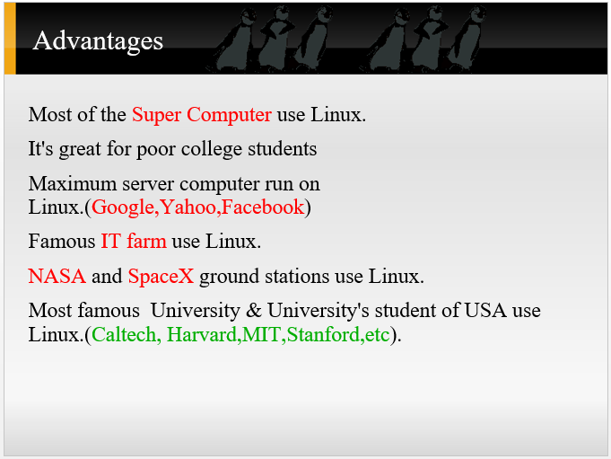

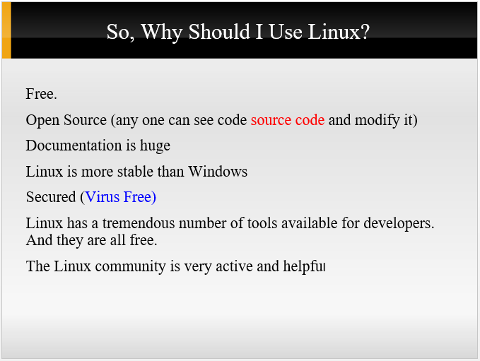

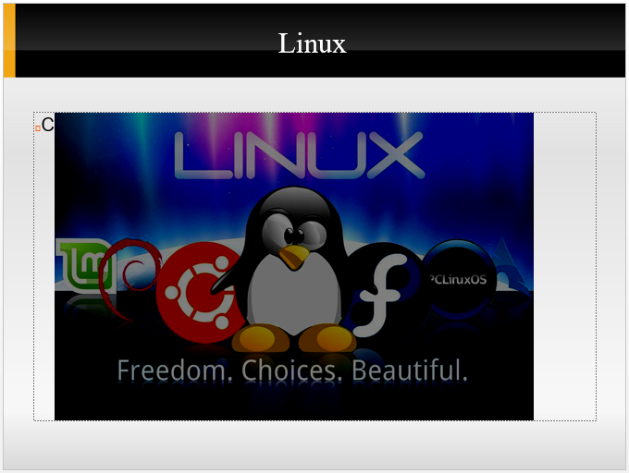

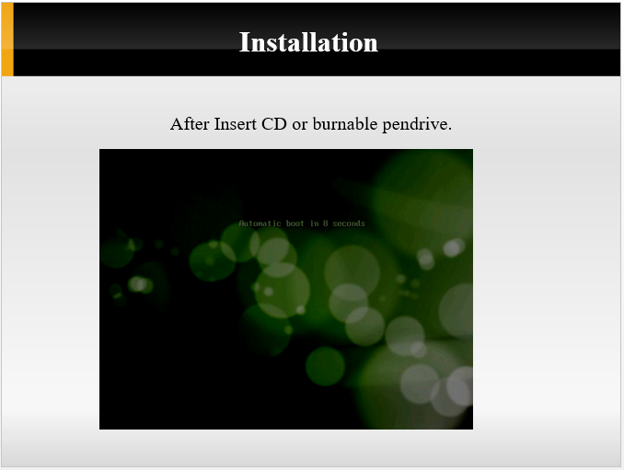

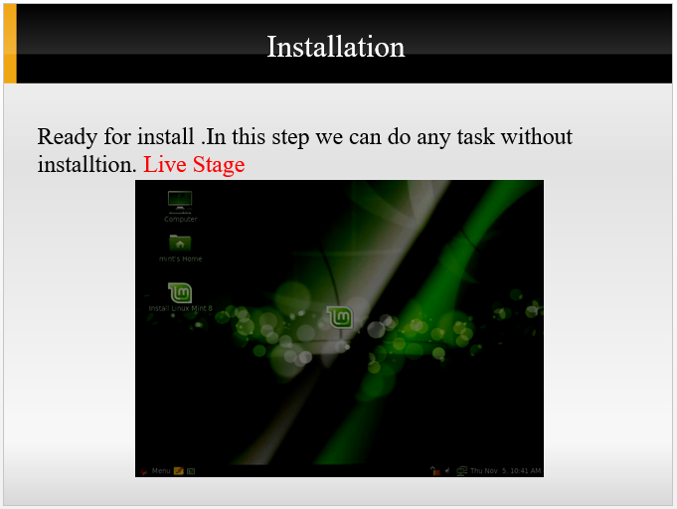

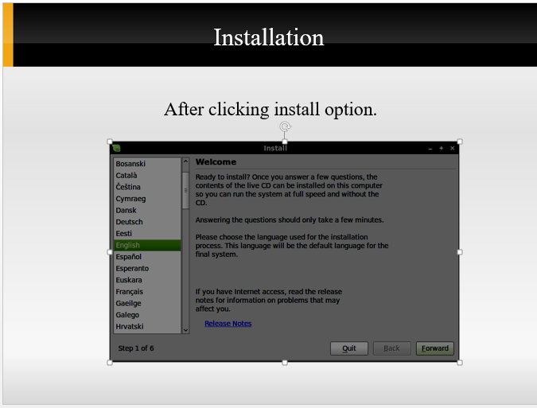

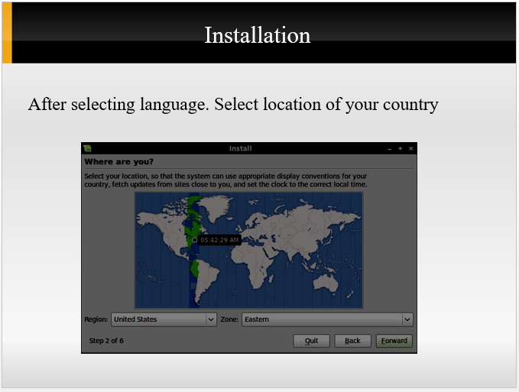

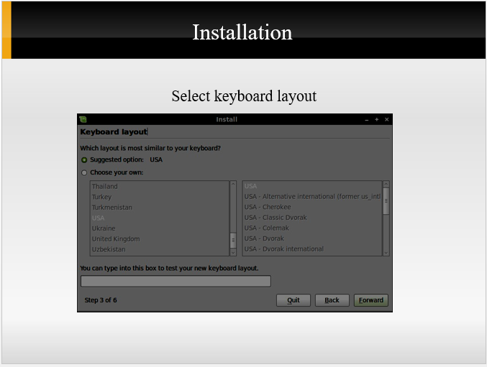

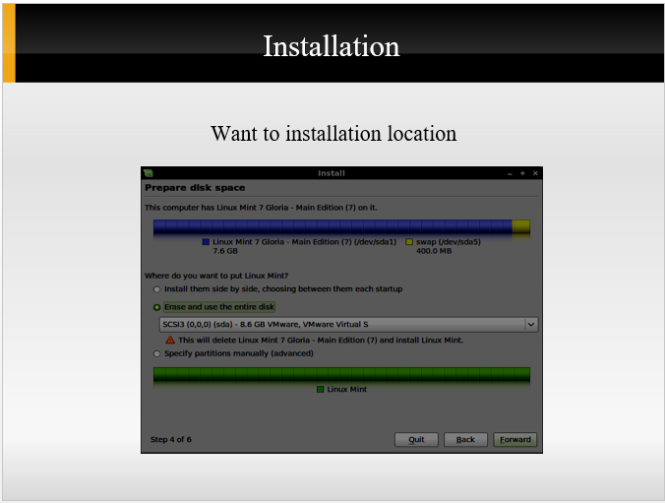

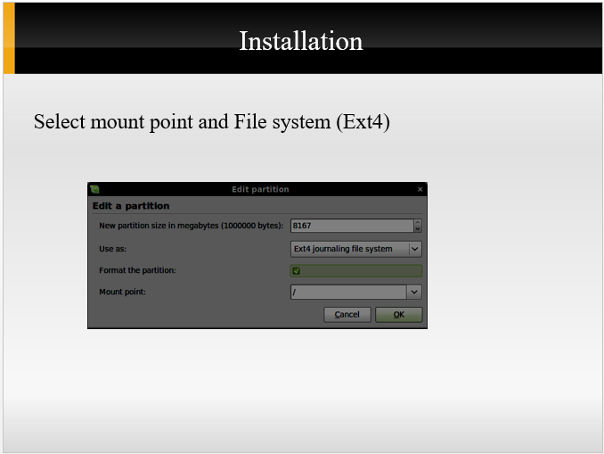

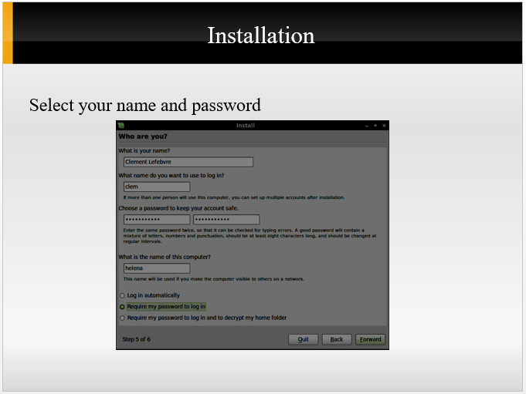

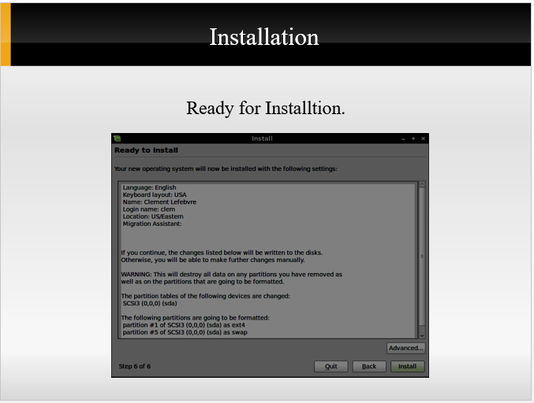

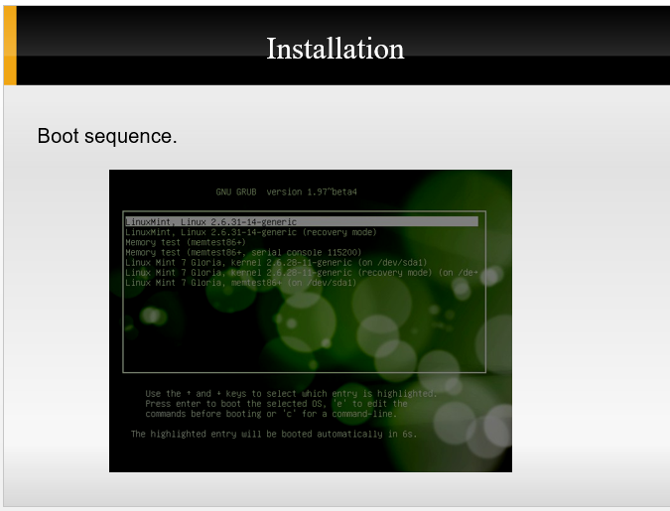

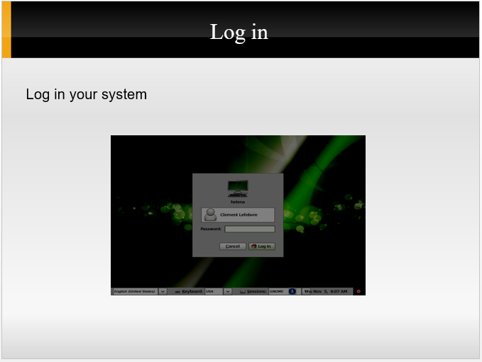

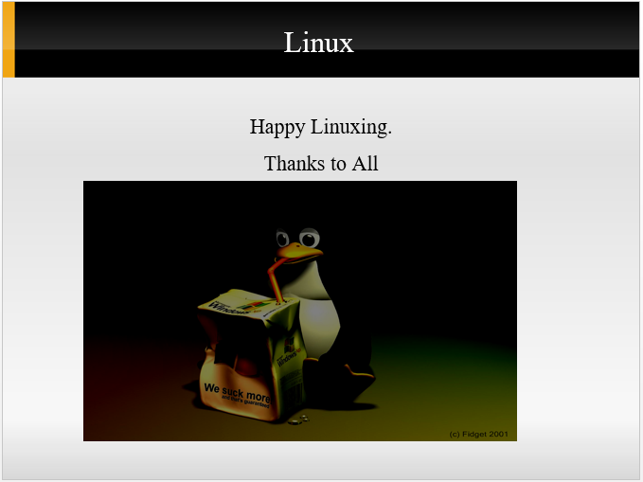

**Conclusion:** Finally, we finish the Linux installation process successfully and it works well. For this purpose, we will be careful of this thing. First, make sure that we’ve backed up any important data on our Windows installation. Since we’ll be modifying our hard drive, we’ll want to store this backup on external media.